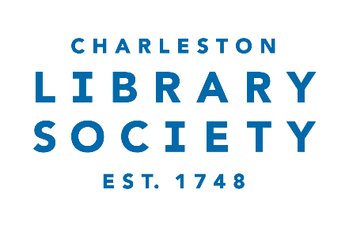

Development and Membership Coordinator (Mid-Level)
Job Description
Job Purpose:
Reporting to the Director of Development & Membership, the Coordinator position is a full-time role responsible for support of the organization’s membership activities including recruitment, retention, and engagement of members and patrons. Areas of focus include (but are not limited to) member and donor database management and administrative tracking, outward communication to members and donors, and internal donor gift processing and follow-up. The ideal candidate is detail-oriented, personable, and passionate about history, libraries, and community engagement. The Charleston Library Society operates from 9AM-5PM daily, with occasional evening and weekend requirements for all full-time team members.
Job Duties and Responsibilities:
- Administer the full membership lifecycle: solicitations, renewals, acknowledgments, and benefits fulfillment
- Implement targeted outreach campaigns to attract new members and re-engage lapsed ones.
- Serve as a point of contact for member inquiries via phone, email, and in person
- Support organization by working 2-3 member programming events per month
- Maintain accurate member records in the CRM
- Track and report on membership metrics, trends, and retention rates
- Work closely with the Development team to align membership efforts with broader fundraising strategies.
- Assist with donor cultivation and stewardship activities as needed.
- Assist with preparation of reports, mailings, and special projects as directed.
- Assist with administration of board materials and set up as directed.

Preferred Qualifications:
- Bachelor’s degree or equivalent combination of education and experience.
- 3–5 years of experience in membership, development, customer relations, or nonprofit administration.
- Strong written and verbal communication skills.
- Excellent attention to detail and ability to manage multiple projects simultaneously.
- Proficiency with CRM systems and Microsoft Office Suite.
- Experience in a cultural, historical, or library setting.
- Knowledge of membership best practices and audience engagement strategies.
- Personable and collaborative, with a customer-service mindset.
- Highly organized and comfortable working both independently and as part of a team.

Compensation & Benefits:
- This position offers a competitive salary range of $42,000-$48,000 per year, plus a comprehensive benefits package that includes $8,200 in employer-provided healthcare insurance, generous paid time off, and a retirement plan with company match.

About Charleston Library Society:
Founded in 1748, the Charleston Library Society, the nation’s second oldest and one of most distinguished libraries, is a cultural institution for life-long learning, serving its members, the Lowcountry community and scholars through access to its rich collection of books, historic manuscripts and archival material and programs promoting discussion and understanding of the ideas they contain. Our members form a vibrant community of scholars, book lovers, and lifelong learners who support our mission to preserve our treasured collection and engage life with curiosity.

How to Apply
Please submit a cover letter, résumé, and three references to Heather Rivet, hrivet@charlestonlibrarysociety.org with the subject line “Development and Membership Coordinator – [Your Name]”. Applications will be reviewed on a rolling basis until the position is filled.

